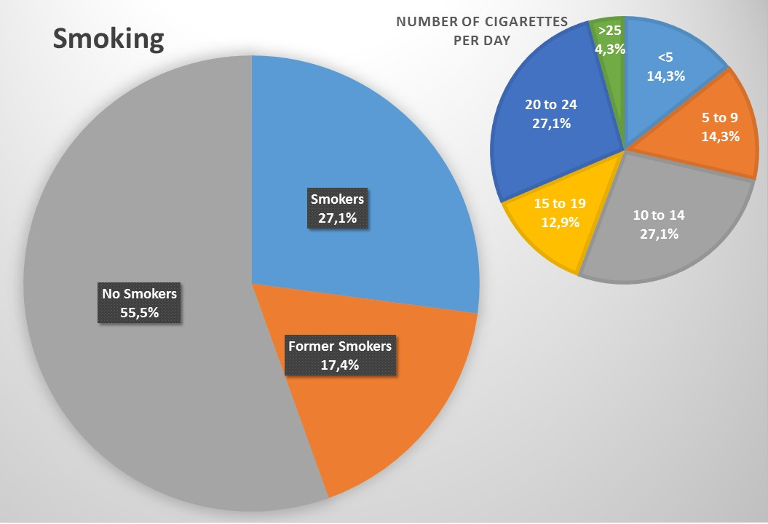
Fig. 1. Distribution of smokers, non smokers and former smokers (left pie) in a sub sample of ENI workers; number of cigarettes a day for smokers (right pie).

